

**College of Engineering and Information Technology**

**Department of Information Technology**

**Information Systems Project [INS 405]**

**Topic:**

GreenChain – Sustainable Food Supply Chain Platform

**Done by:**

|  |  |  |  |  |  |
| --- | --- | --- | --- | --- | --- |
| **Student Name** | Sara E. S. Alnajjar | **Student ID** | 202110946 | **Major** | IS E- Business Management |
| **Student Name** | Joti Rani Biswas Anukul Ram | **Student ID** | 202011604 | **Major** | IS E- Business Management |
| **Student Name** | Rayan Hassan Farhan | **Student ID** | 201920024 | **Major** | IS E- Business Management |
| **Student Name** | Ebtehal Rami Mohammed Ahmed | **Student ID** | 202010020 | **Major** | IS Project Management |

**Supervised by:**

Dr. Shafiz Bin Mohammed Yousef

**Fall Semester 2024-2025**

**Acknowledgement**

We would like to express our deepest gratitude towards Dr. Shafiz Yusof, our graduation Supervisor, he has been a great help on this journey and has helped us throughout our graduation project. He gave us directions, unwavering support and endless amounts of encouragement throughout our project, without his help we would not be able to have completed this project the right way. Nevertheless, he made it easier for us to decide on what the project should be, what the layout should be like and so forth, all our questions were always answered by him, so we thank him for the endless number of insights and support, he has been the backbone of our team.

We would also like to thank Mr. Moammar Al Saidi for helping us come up with the foundation and concept for GreenChain. He told us what was one of the main challenges in the food industry today and that helped us be able to create a sustainable food supply chain website, so we thank him for providing us with his contribution towards our idea.

Moreover, we would also like to thank all the other individuals that were involved in our midterm presentations, our project and so forth, as well as anyone else that may have provided their resources or expertise or any other contribution, no matter how small.

Furthermore, we are extremely thankful and forever indebted to everyone who has supported us, this achievement is yours just as much as it is ours.

**Abstract**

GreenChain was developed to solve important issues with food supply chains, such as waste, inefficiency, and environmental effects. With growing concerns about unsustainable consumption patterns, hunger, GreenChain offers a platform that connects eco-friendly consumers with sustainable suppliers. GreenChain wants to enable communities to decrease food waste, encourage responsible consumption, and support environmentally conscious habits by highlighting sustainability, and local sourcing. This will help achieve global sustainability goals.

**List of Abbreviation**

* **HTML** - Hypertext Markup Language
* **CSS** - Cascading Style Sheet
* **DBMS** - Database management system(Velo)
* **UI** - User Interface
* **SEO** - Search Engine Optimization
* **JavaScript Optimization**

Table of Contents

**Chapter One: Introduction** 8

1.1 Background 8

1.2 Motivation and Problem Statement 8

1.3 Objectives 9

1.4 Target Users & Stakeholders 10

**Chapter Two: Literature Review** 10

2.1 Journals 10

2.2 Similar Work 12

2.3 SWOT Analysis 13

2.4 Market Analysis 14

2.4.1 Market Overview 14

2.4.2 Market Trends 14

2.4.3 Market Segmentation 14

2.4.4 Competitive Landscape 14

2.4.5 Market Opportunity 15

2.4.6 Market Entry Strategy 15

**Chapter Three: Planning and Requirements** 15

3.1 Project Requirements 15

3.1.1 Regulatory and Compliance Requirements 15

3.1.2 User Requirements 16

3.1.3 Marketing and Sales Requirements 16

3.2 Project Plan 16

3.2.1 Gantt Chart 16

3.2.2 Project Phases/Tasks 17

3.2.3 GreenChain Project Plan 18

3.3 Project Constraints 20

3.4 Project Risks 20

3.5 Project Methodology & Approach 20

3.6 Requirements Gathering Technique 21

3.7 Functional Requirements 21

3.8 Non-Functional Requirements 22

**Chapter Four: Project Analysis and Design** 23

4.1 Use Case 23

4.2 Activity Diagram 25

4.2.1 Customer Process Activity Diagram 25

4.2.2 Food Bank Donation Activity Diagram 26

4.3 Domain Class Model 27

4.4Sequence diagrams 28

4.4.1 Order Sequence 28

4.4.2 Foodbank Sequence 29

4.5 User Interface Design 30

4.6 Architecture Diagram 32

4.7 Network Diagram 32

**Chapter Five: Implementation** 34

5.1 Environment 34

5.1.1 Hardware Component 34

5.1.2 Software Component 34

5.1.3 Network Configuration 34

5.2 Technologies Needed 35

5.3 Programming Languages and Database Systems 35

5.4 Evaluation/Testing Measures 37

5.5 Testing Plan 41

5.6 Implementation Plan 43

**Chapter Six: Conclusion** 53

6.1 Strengths and Weaknesses 53

6.2 Improvements for the Future 54

6.3 Conclusion 54

References 55

Appendix 56

**Table of Figures**

**Figure 1: Gantt Chart View 17**

**Figure 2: Work Breakdown Structure 18**

**Figure 3: GreenChain Use Case View 25**

**Figure 4: Customer Process Activity Diagram 26**

**Figure 5: Food Bank Donation Activity Diagram 27**

**Figure 6: Domain Class Model View 28**

**Figure 7: Order Sequence Diagram 29**

**Figure 8: Foodbank Sequence Diagram 30**

**Figure 9: User Interface-1 31**

**Figure 10: User Interface-2 31**

**Figure 11: Architecture Diagram 32**

**Figure 12: Network Diagram 33**

**Figure 13: Dev Mode View 35**

**Figure 14: JavaScript for Consumer Registration 36**

**Figure 15: CMS View for Customers 37**

**Figure 16: Data Stored In Donate Now Collection 38**

**Figure 17: Order Confirmation Email 39**

**Figure 18: Dropdown Menu 39**

**Figure 19: Mobile Responsive View 40**

**Figure 20: Admin Dashboard View 41**

**Figure 21: Input Validation View 42**

**Figure 22: Add to Cart Functionality Testing 42**

**Figure 23: Website prototype using Figma 44**

**Figure 24: Home Page View 45**

**Figure 25: Supplier & Consumer Registration Page View 46**

**Figure 26: Login Page View 47**

**Figure 27: Consumer Profile Page View 47**

**Figure 28: Supplier Profile View 48**

**Figure 29:Products Page View 49**

**Figure 30: Food Bank Donation Page View 50**

**Figure 31: Charity Partners View 51**

**Figure 32: Support and Feedback Page View 52**

**Table of Tables**

**Table 1: FoodLogiQ vs GreenChain 13**

**Table 2: Project Plan, Roles, and Responsibilities 20**

**Table 3: Functional Requirements 22**

**Table 4: Non-Functional Requirements 24**

# **Chapter One: Introduction**

## 1.1 Background

Traditional food supply chains often face inefficiencies, such as over-ordering, food spoilage because of poor storage practices, and lack of transparency on the sourcing and production processes. However, these inefficiencies lead to food waste and have a major negative impact on the environment through carbon emissions and resource mismanagement.

GreenChain aims to address these issues by developing an e-commerce platform that makes purchasing and selling food products from sustainable sources easier. The platform provides ease of use and helps businesses make responsible, eco-friendly decisions by connecting consumers with sustainable food suppliers.

In today’s food industry, supply chain management requires transparency, sustainability and being able to handle costs and help with demand. The GreenChain website will be able to help businesses to reduce waste and optimize inventory, whilst also giving sustainability solutions through local sourcing, this will not only help with the environment but also help companies to stay competitive and responsible. This website's main aim is to meet the food industries' needs and provide the best supply chain management system.

## 1.2 Motivation and Problem Statement

The global food industry has many issues extending from defective supply cycle processes to food waste, especially in the developed nations, yet the world is experiencing malnutrition. These issues are what GreenChain was designed to address using technology and further the cause of sustainability. Our project's motivation is to significantly impact food security, sustainable consumption and development as captured by these three Sustainable Development Goals (SDGs). GreenChain wants to completely transform the way suppliers, restaurants, and cafés operate so they can use sustainable practices while still achieving their business goals.

* + 1. **Responsible Consumption and Production (SDG 12)**

One of the major global issues today is the unsustainable production and consumption practices that dominate the food industry. These practices lead to resource depletion, environmental pollution, and overproduction, all of which harm the environment. GreenChain addresses this problem through sustainable sourcing, helping businesses find suppliers that follow eco-friendly production standards and minimize waste.

Additionally, GreenChain encourages businesses, such as restaurants and cafes, to donate unsold food to communities in need, preventing waste and supporting vulnerable populations. The platform also emphasizes a circular economy, offering systems for recycling and reusing packaging and food materials. This helps shift from a traditional linear consumption model to a sustainable, circular one, supporting companies in their efforts to embrace environmentally friendly practices.

* + 1. **Zero Hunger (SDG 2)**

Although there are enough crops produced worldwide to feed everyone, food insecurity is still a problem. The problem stems from unequal resource distribution and significant food waste in developed countries. GreenChain addresses this by incorporating a food donation system that reduces waste. Restaurants and cafes can donate leftover food through the platform, ensuring it benefits food banks, shelters, and organizations serving the community, rather than going to waste. By connecting businesses with extra food to those in need, GreenChain helps fight hunger directly. Its long-term goal is to ensure that surplus food is distributed efficiently, ensuring those who need food receive it. This initiative aligns with the goal of Zero Hunger, not just as a supply chain solution but as part of a broader effort to create a sustainable food system that responds to changeable supply and demand while addressing one of humanity's greatest challenges.

* + 1. **Industry, Innovation, and Infrastructure (SDG 9)**

GreenChain supports small-scale local and regional producers of eco-friendly food, helping them overcome challenges like limited infrastructure and market access. By providing an online marketplace, these producers can connect with businesses seeking sustainable products, opening new economic opportunities. As a result, the food industry is encouraged to innovate and adopt sustainable and eco-friendly techniques.

Additionally, GreenChain empowers small-scale producers to compete on a larger scale, building a resilient and sustainable foundation for the food industry. As sustainability become more standard, the platform drives long-term improvements in the food supply chain, making the industry more efficient and environmentally responsible.

## 1.3 Objectives

The main objective of this project is to develop a website that will improve the supply chain system for restaurants and coffee shops, by ensuring efficiency, cost-effectiveness, and sustainability.

* + 1. **Efficient Raw Material Ordering System:**

This website will provide an interface that will allow restaurants and coffee shops to easily order raw materials, whenever there is a food shortage, by ensuring real-time availability and pricing from multiple manufacturers.

* + 1. **Excess Food Management:**

GreenChain provides a feature to manage excess food, by enabling restaurants and cafes to redistribute food to the partner charities to prevent food waste.

* + 1. **User-friendly Interface:**

Provide a seamless experience for the users with a responsive design that includes mobile accessibility, by coordinating with restaurant theme to create a coordinated experience.

* + 1. **Environmental Sustainability:**

GreenChain reduces food waste by managing excess inventory. It also offers an option to redistribute surplus food to charities, by utilizing eco-friendly packaging and delivery.

## 1.4 Target Users & Stakeholders

The main stakeholders are restaurant owners and managers, who have a key interest in the processes and financial parts of the supply chain system. Employees, Suppliers and Shareholders can also be stakeholders which are mainly concerned with how profitable the supply chain is to the restaurant.

The target users for GreenChain are also restaurants and coffee shops, which can be small or big businesses, the challenges faced by these businesses are shortages or surplus inventory. GreenChain offers solutions on how to manage these issues as well as reduce waste, by ensuring a food supply that is always available as well as sustainable alternatives.

Another target user for GreenChain is suppliers, which follow sustainable practices but find it difficult to reach businesses that are on the same wavelength. GreenChain offers a way to connect these suppliers to restaurants and coffee shops that share the same interests when it comes to the preservation of the environment through an e-commerce space that allow them to reach a wider market reach.

Moreover, non-profit organizations also benefit from GreenChain, as we create a link between restaurants and non-profit organizations, making it easier for excess food to be provided to those in need through food banks and charities.

# **Chapter Two: Literature Review**

## 2.1 Journals

**Supply Chain**

Supply chain management is the processing of all activities in an organization from production essentially from the farm to the warehouse and so forth. SCM ensures products are delivered and distributed effectively, ensuring low costs and high quality. SCM reduces costs, minimizes waste and reduces risks as well as increasing customer satisfaction. SCM is essential for all businesses to meet organizational goals and sustainability goals. (IBM, 2024)

The supply chain and demand visibility have a great impact on product innovation. It shows that firms can gain valuable external information but need a strong internal capability to use it for innovation. It also highlights how supply chain integration with suppliers, customers, and internal processes is important in turning visibility into an innovative outcome. By integrating with these partners, the businesses can collaborate better, share information, and respond to market changes. The study further explains how these three types of supply chain integration influence the relationship between visibility and innovation, offering insights into how businesses can use supply chain information to drive both exploratory and exploitative product innovation, which will lead to competitive advantage. (Hu, 2023)

Due to globalization, sustainable supply chains have become increasingly important as they help supply chain members connect globally. There are various reasons for this, such as stakeholder pressures, customer demand, and other environmental or economic reasons. Regardless of all the benefits sustainable supply chains bring, there are challenges related to their complexity, such as how to interconnect supply chains. Research also shows us that sustainable and environmentally friendly packaging of products can also improve economics and customer satisfaction. (Mastos, 2022)

**Food Industry**

The food industry is all the activities from the production of the product to meet the needs of food organizations. The food industry includes multiple sectors from manufacturing, food technology, servicing of food and so forth. This industry is important for everyone, and it drives economic growth, even whilst going through multiple challenges such as ensuring food safety, adapting to evolving customer needs and ensuring technology also plays a role in achieving different aspects of innovation and sustainability, as digitalization is becoming a leading factor for all industries. (Resource, 2024)

The food industry sector is important for all things related to nutrition, health and the economy. This industry is everything from agriculture to the distribution of foods, it consists of multiple ranges of products such as fruits, vegetables, bakery items and meat. Technology is being used to automate these processes and enhance and provide sustainability within this industry. Despite being a challenging industry that faces issues such as regulatory and compliance issues related to lack of transparency and so forth, it is still a highly evolving industry that is open to multiple opportunities and future enhancements that are vital for global health and the world economy. (Sadiku, 2019)

The worldwide food sector plays an important role in leading change toward sustainability, but it also damages the environment. This study focuses on examining the importance, methodologies, and current research on how the food business may promote sustainability. Climate change, resource shortages, food security, and health concerns are some of the issues that the food industry must address. The customers, policymakers, and stakeholders are fighting for companies to lower carbon footprints, purchase supplies ethically, reduce waste and improve food's nutritional value. This paper also highlights the shift in consumer preferences toward sustainable and healthier diets as a key factor, by promoting plant-based diets and using environmentally friendly ideas are all vital for sustainable consumption. (S. Prasanna, 2024)

**Supply Chain and Food Industry**

For most supply chains, the primary focus is enhancing transparency and agility to meet the difficult challenges set by supply and demand chains, all whilst managing costs well. Through integration and demand forecasting, businesses can optimize inventory and reduce waste. Information sharing between all partners and suppliers can improve the allocation of resources and can also save costs throughout the entire supply chain. Industry experts have also shared how important leveraging technology can be for the supply chain. (Enterprises, 2024)

A sustainable supply chain is eco-friendly and ethically responsible, which helps businesses become more competitive and more successful within the market. Sustainable supply chains also provide transparency from sourcing to recycling. (SAP, n.d.)

Sustainability supply chains are important for businesses to flourish in today’s market. Many businesses and customers are more conscious of sustainably and prioritize environmentally friendly businesses, this influences partnerships and how a business thrives. For businesses, sustainability is now more of a competitive stance to attain more customers and meet their needs, so having a sustainable supply chain can enhance their business and attract more customers which would increase profits made. (Gelato, 2024)

Sustainability is shaping the future based on this success story in this journal where the business “Farm Burger” explains the importance of the direct-to-source supply chain practices that led to high-quality products and increased transparency even throughout difficult times such as COVID-19. This story also emphasized how crucial sustainability is when it comes to the impact on the environment and providing stability in uncertain times. (Magazine, 2023)

## 2.2 Similar Work

FoodLogiQ is a comprehensive supply chain management software designed by Trustwell for the food industry. FoodLogiQ mainly focuses on quality assurance, compliance, traceability, and recall. Our goal is to create an efficient supply chain software that incorporates additional features as well as supporting sustainability.

|  |  |  |
| --- | --- | --- |
| Features | FoodLogiQ | GreenChain |
| |  | | --- | | Food safety |  |  | | --- | |  | | Yes | Yes |
| Eco-Friendly | No | Yes |
| Compliance | Yes | Yes |
| Sustainable Supplier Focus | No | Yes |
| Waste Reduction | No | Yes |
| Consumer-facing E-commerce Platform | No | Yes |

Table : FoodLogiQ vs GreenChain

## 2.3 SWOT Analysis

**Strengths**

* **Focus on Sustainability**: GreenChain’s core value is promoting sustainable practices in the food supply chain, appealing to the growing eco-conscious consumer base.
* **Waste Reduction**: Businesses can cut expenses while addressing environmental issues by using tools to manage inventories and reduce food waste.
* **Local Sourcing**: Local economies are supported, and transportation production is decreased when local suppliers are encouraged.

**Weaknesses**

* **High Implementation Costs**: The high cost of developing and maintaining technology
* **Supplier Network Development**: Establishing a network of verified sustainable suppliers might take some time.
* **Reliance on Consumer Education**: The key to success is educating customers and businesses about how the platform works and the importance of sustainability.

**Opportunities**

* **Expanding into food waste recovery:** Connecting consumers(Restaurants & Coffee shops) with charities or composting solutions for surplus food.
* **Expansion to International Markets**: GreenChain could scale its solution to different regions and supply chains worldwide as sustainability becomes a global focus.
* **Corporate Social Responsibility (CSR)**: Businesses with a CSR focus might be more likely to use GreenChain to improve their public perception and sustainable practices.

**Threats**

* **Competition**: Existing platforms like IBM Food Trust and SAP offer similar services in supply chain management and transparency.
* **Regulatory Challenges**: Expanding into new markets may be more difficult if supply chain and environmental rules change by area.
* **Resistance to New Technology**: Traditional food suppliers and small businesses may be hesitant to accept new technology or change to more open business practices.
* **Economic Downturns**: Businesses may put cost savings ahead of sustainability during economic downturns, which might reduce demand for GreenChain's services.

## 2.4 Market Analysis

Market analysis helps us introduce our website and services by understanding industry trends, identifying our target, and analysing both risks and opportunities for GreenChain.

### 2.4.1 Market Overview

The food industry is highly dynamic and mostly depends on a big supply chain to meet the demand of restaurants and coffee shops. With the increasing need of the consumer for fresh and quality materials GreenChain will work as a central hub off supply chain for restaurants and cafes to improve their business productivity.

### 2.4.2 Market Trends

The food-related market is gradually turning digital, especially restaurants and coffee shop businesses are implementing digital technologies to manage the supply chains. This will allow them to order supplies more easily and manage their inventory by monitoring their stock level. Another emerging trend in which technologies are used to minimize the level of food waste is by managing excess food, either through redistribution or pre-inventory planning. Additionally, AI and process automation play a key role in supply chain management, by making the processes faster and more efficient. Therefore, our aim is for GreenChain to integrate with multiple market trends to provide consumers with a seamless experience.

### 2.4.3 Market Segmentation

The GreenChain segments its market for small to medium-sized businesses, which is focused on three primary user groups, and they are Restaurants and Coffee shops. Restaurants are a key market because they often struggle to manage their inventory, which leads to food shortages or over-purchasing of materials and operating on fewer budgets. The GreenChain also provides an efficient system for coffee shops to order their daily supplies like milk and baked goods. Therefore, this will help the users to improve their business and market value.

### 2.4.4 Competitive Landscape

GreenChain is surrounded by multiple competitors, such as IBM Food Trust, which helps businesses track their products from the production stage all the way to the consumer plate, ensuring the product is safe as well as sustainable. Another is SAP’s Sustainable supply chain solution, which focuses on reducing environmental impacts for the companies by reducing carbon emissions and optimizing product transportation. On the other hand, Fair Food Network helps to develop a sustainable food system that will support the local farmers and reduce waste. Finally, FoodLogiQ, helps restaurants and suppliers to know the origin of the product that is delivered to them. However, many competitors do not offer an integrated system, whereas GreenChain offers a unique combination of integrated features for managing both raw materials shortages and food excess.

### 2.4.5 Market Opportunity

The GreenChain has a significant market opportunity, with the possibility of rapid acceptance and scalability across several restaurants and coffee shops. Where GreenChain also offers an easy-to-use e-commerce platform for users that will streamline their ordering. It also can foster cooperation with other brands that are aligned with food waste reduction programs, eco-friendly organizations, and local and organic food suppliers to promote sustainable practices in the food industry, which will also increase GreenChain's visibility and market reach. GreenChain also has the opportunity to expand in the global market, especially in countries with strong sustainability policies such as Europe.

### 2.4.6 Market Entry Strategy

There are multiple steps for GreenChain to enter the market space. First, consider partnering with local suppliers to develop a reliable network and try building trust among different communities. Secondly, target small and medium-sized businesses that are often overlooked by competitors and provide them with a cost-effective solution to solve their problems. Third, GreenChain should differentiate itself from the crowd by offering its unique integrated features. Lastly, allow the users to have a free trial or low-cost subscription to GreenChain, which will allow the users to experience the benefits of the web site.

# **Chapter Three: Planning and Requirements**

## 3.1 Project Requirements

GreenChain's requirements include compliance with data privacy and sustainability regulations, having user-friendly features for consumers, and suppliers, and highlighting its sustainability commitment through marketing. Altogether, these components ensure the effectiveness and success of the platform.

### 3.1.1 Regulatory and Compliance Requirements

GreenChain's regulatory and compliance requirements are centered on making sure the platform complies with legal requirements and sustainability standards. GreenChain is required to follow data privacy rules and ensure the safe processing of user data through regular audits. However, to promote sustainability objectives like carbon reduction and ethical sourcing, the platform must also align with environmental rules. Compliance with e-commerce laws related to digital contracts, consumer protection, and dispute resolution is also important.

### 3.1.2 User Requirements

GreenChain’s user requirements are meant to meet the needs of all users. Our platform is very straightforward, user friendly and very easy for suppliers and consumers to understand the way it works. This makes it easier for the consumers and suppliers to easily get on board with us and considering that we are a highly prioritizing sustainability website this will guarantee we will draw in the right users. Our platform also provides multiple features such as search bar, filters, navigation bar and other clickable features. All these tools and buttons are fast and simple to use, this makes users have a smooth and seamless experience. We also provide educational hubs that explain the importance of sustainability in the food industry. Additionally, we also provide feedback and support so that any user concerns/feedback are considered so that we can better help meet the needs of our customers and suppliers. We aim to provide the best operational services, and we ensure that there is integration between everything and there is proper service management.

### 3.1.3 Marketing and Sales Requirements

GreenChain's marketing and sales requirements focus on building a strong reputation that highlights the company's attention to sustainability and quality of the food supply chain. A focused marketing strategy highlighting important features and benefits of the products that align closely with the target audience's needs. By focusing on onboarding local, ethical, and sustainable suppliers, the strategy ensures a wide choice of products and helps to develop a strong supplier network. Additionally, marketing strategies that target consumers interested in eco-friendly products are given priority.

## 3.2 Project Plan

This part covers all the formal documentation used to build GreenChain, ensuring quality and timely delivery of the project. This documentation consists of a Gantt chart, Project Phases and Tasks, Project Scope, Deliverables, Roles & Responsibilities, Project Constraints, Project Risks, Project Management Methodology & Approach, and multiple Requirements Gathering Techniques.

### 3.2.1 Gantt Chart

A Gantt Chart is useful for organizing the project timeline, tasks, dependencies, and key goals. We used it to plan GreenChain and created a clear and detailed roadmap for the project. This chart shows when the tasks must be completed, what depends on what, and the key milestones we need to reach. It allows us to ensure that all the activities are completed on time, the resources are allocated properly, and the project stays on track to meet its overall goals and objectives. Following this approach will allow us to better manage our workload and avoid work delays. The detailed work breakdown structure that we have created for GreenChain is shown in the below Figure.

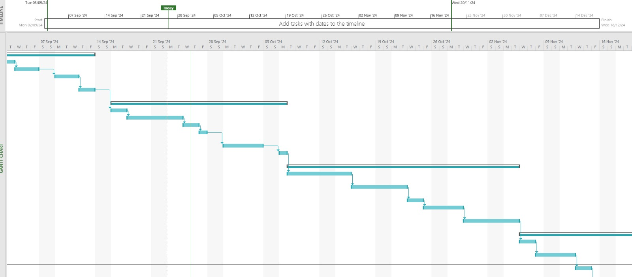

Figure : Gantt Chart View

### 3.2.2 Project Phases/Tasks

The development of GreenChain followed a structured process, which is divided into six phases. Starting with the Planning phase, where the project goal, objective, and scope were defined, alongside identifying stakeholders’ needs. The consumer needs and demands were determined through market analysis, resulting in the creation of a detailed project plan outlining timelines, milestones, and resource allocation. The Design Phase is involved in creating a prototype for the website and building the front-end and back-end components of the website. Creating a user-friendly interface along with fast-moving features, by obtaining feedback from the group members. Design and create a database for the website and after finalizing the design of the website get project supervisor approval. The Development Phase involved creating back-end architecture like database and API development. Alongside developing features like surplus management systems, while integrating the system with third-party services like payment processing and raw materials manufacturers. Next is the Testing phase, this phase consists of various scenarios and multiple types of testing like system testing, functional testing, performance testing, vulnerability testing, and usability testing to find the flaws on the website and fix them. The Deployment Phase involves developing and communicating website launch plans to the stakeholders, conducting user acceptance testing, executing the deployment plan, monitoring system performance, and addressing immediate issues. Finally. The Maintenance Phase involves creating a maintenance schedule for regular updates, monitoring website performance providing support to the customer and reviewing and updating the system regularly.

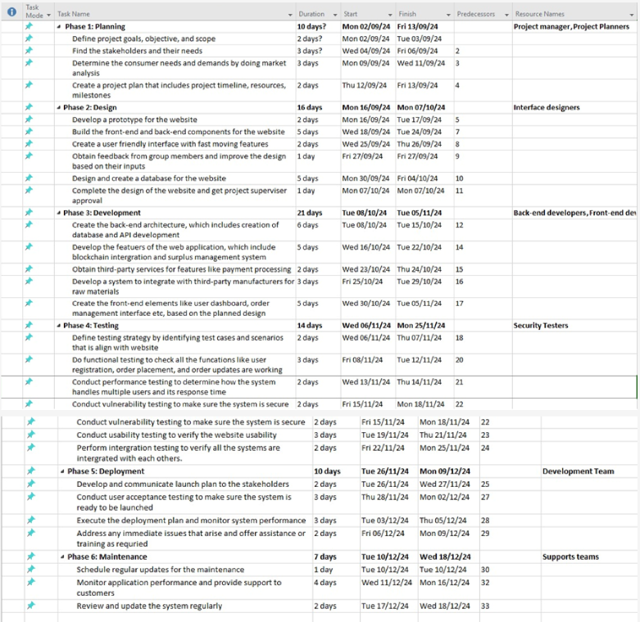

Figure : Work Breakdown Structure

### 3.2.3 GreenChain Project Plan

|  |  |
| --- | --- |
| **Project Scope** | |
| GreenChain is an E-commerce platform that was designed to connect eco-conscious restaurants and coffee shops to sustainable food suppliers. This project is mainly focused on creating an e-commerce website that consumers can order from, and it aims to reduce food wastage through providing services where Food bank requests can be made by customers to be circulated and redistributed to those in need | |
| **Deliverables** | |
| Sustainable website | A wide variety of suppliers and products that are proven to be sustainable will be provided by GreenChain. |
| Waste Management features | Tools used to enhance inventory and reduce food wastage, through recycling and providing to food banks. |
| Easy User Interface | GreenChain provides user friendly website that is easy to navigate through, which will streamline user experience. |
| **Roles & Responsibilities** | |
| Project Manager | Responsible for managing the entire project and its execution.  In charge of communication with stakeholders.  In charge of making sure the project stays within the scope and budget that was set. |
| Technical Architect | Manages the website’s technical development, including its integration, functionality, and other technical components.  Ensure the website meets the technical requirements. |
| Front-end Developer | Responsible for designing the user interface of the platform, making sure it is user-friendly and accessible to all users. |
| Back-end Developer | Responsible for the website’s main functionalities, such as inventory management, how to process different orders and database functionalities. |
| Marketing Team | Responsible for different marketing strategies and advertising GreenChain to different businesses. |
| Quality Assurance Team | conducts extreme testing to make sure the platform is functional, secure and can easily be used. |

Table : Project Plan, Roles, and Responsibilities

## 3.3 Project Constraints

One of the potential constraints for this project could be budgeting, which could come from the high integration and use of AI costs, which could potentially lead to a financial crisis. Another constraint could be with the time, delays from any supplier could lead to challenges for this project, as this project is created as an immediate solution for restaurants and coffee shops. Getting the right suppliers for GreenChain can also be a constraint as it may take a long time to adopt the right suppliers for this platform. Additionally, other constraints could be technical complications with implementing difficult features that could also take up more time.

## 3.4 Project Risks

A few risks that could be expected from this project are technological risks that could come from the system itself, which would lead to delays. There could also be security risks which could lead to unauthorized access to data, which could then lead to target users losing trust in the platform. Other risks could be related to competition risks, adoption risks and risks related to not being able to correctly verify suppliers that are aiming for sustainable goals which could impact the rate at which the platform grows.

## 3.5 Project Methodology & Approach

For this project we will incorporate sprint development, this allows for iterative development of the platform by breaking the project into different sprints and conducting regular assessments. This project will also have cross-functional teams that work collaboratively together to ensure the project is aligned and in sync. Additional methodologies will be creating prototypes and testing them to be able to identify any technical/non-technical issues.

Other approaches in this project will be providing regular reviews to evaluate project progress, making any adjustments to scope and continuous feedback to stakeholders to ensure all project needs are met and we are making progress. Milestones will also be tracked to make sure we are on target with project goals and objectives.

**Our methodology/approach for this project is as follows:**

* **Planning**

For this phase, we will start off by assessing what will be needed for the project through conducting meetings with stakeholders to identify the project requirements, we will then proceed to research the market to identify unique value suggestions for our platform. We then proceeded to define the project scope as defined earlier and we finally conducted a risk analysis to develop strategies to reduce these risks.

* **Design**

In this phase, we will focus on designing the system architecture, designing the user interface and planning and storing data accordingly.

* **Development**

For this phase, we will be focusing on developing all the functionalities (functional and non-functional) features for the platform such as adding products, consumer and supplier profile, and integrated food bank management system.

* **Testing**

For this phase, we will conduct vigorous testing, through component testing of each unit, testing to ensure integration, user experience testing to ensure users are happy with the platform and finally security testing to minimize security issues.

* **Deployment**

For the deployment phase, we will focus on launching through ensuring proper user training has been provided and deploying through live strategies. We could also do an alternative between soft launching or full launching through marketing and using other engagement techniques.

* **Maintenance**

This is the final stage of project methodology, where we focus on the maintenance and monitoring of the platform. Regular updates and adjustments are done in this stage such as software updates or adjustments due to user feedback. Performance is also monitored through metrics and feedback is taken into consideration to create improvements on the platform.

## 3.6 Requirements Gathering Technique

GreenChain's requirements-gathering process started with an interview with Mr. Moammar Al Saidi, Chief Technology Officer of OMNES Technologies. He gave an overview of the concept and underlined the significance of developing a platform to increase food supply chain efficiency and transparency. The project team held a meeting after the interview to define key features, discuss and summarize the insights received, and lay out a development roadmap. Selecting Wix as the development platform and defining team roles to ensure alignment with the project's objectives were also discussed.

## 3.7 Functional Requirements

These functional requirements ensure that GreenChain effectively meets a variety of user needs while encouraging accountability and sustainability in the food supply chain.

|  |  |
| --- | --- |
| **Functional Requirements** | **Description** |
| **User Registration and Authentication** | To facilitate the set-up of accounts for suppliers, GreenChain will introduce a secure registration and authentication process. Users will have to create secure accounts and supply the required data. |
| **Order Processing and Payment** | Orders can be placed and managed by using GreenChain's order processing system. The platform will integrate several payment methods, including digital wallets cash and delivery, to offer an easy transaction experience. The purpose of this feature is to improve customer satisfaction and promote repeat purchases. |
| **Customer Support** | There will be a support and feedback page where users will be able to provide their feedback on different services they received. For example ordering service, food bank donation service and so forth, additionally there will also be a section on support if there are any questions or concerns that users might have, they can provide their contact details and we will get back to them and this contact information will be sent as a form submission notification with different details to our dashboard so we can contact them and answer/resolve any concerns. This will ultimately help us engage and build trust with our customers by providing a strong support system. |

Table : Functional Requirements

## 3.8 Non-Functional Requirements

These non-functional requirements are essential to ensuring that GreenChain functions in an effective and inclusive manner, offering satisfying user experience and advancing sustainability in the food supply chain.

|  |  |
| --- | --- |
| **Non-Functional Requirements** | **Description** |
| **Performance** | High performance is required for GreenChain to manage many real-time users and transactions without lag. For maximum user experience, the platform should load in less than three seconds. Scalability is necessary so that the system can grow as user demand does. |
| **Compatibility** | Tablets, smartphones, and desktops should all be able to use the platform with a variety of devices and operating systems. For the experience of users to be standardized across platforms, it must support the major web browsers. Whatever their preferred device, customers will be able to conveniently access GreenChain because of this compatibility. |
| **Accessibility** | To ensure that consumers with minimal knowledge of technology can browse, purchase, and maintain our accounts, the platform will have a simple user interface with easy access. |

Table : Non-Functional Requirements

# **Chapter Four: Project Analysis and Design**

## 4.1 Use Case

The diagrams show the process of the GreenChain website and its Food Bank. which goes as follows, The Consumer must register an account on the website and later he/she can log in to their account to explore the website, Let’s focus on the main functionality, where the Consumer can view and update their profile information. Later the consumers can browse products on the website and choose their favorite items and place order. After placing an order, it will move the consumer to checkout page and allow them to make payment. It also helps the consumer to view their order history. Next moving to Admin, who has to login to the website, the admin control and handle multiple things, were it allow the admin to view order history. Later the admin must manage their inventory to keep track of their food stocks and update it based on requirements, and it also tracks the sales process. The admin is also responsible for uploading products on the website as well as managing the promotion and discounts related to the products. Moving into the supplier, the supplier should also register and log in to the website, they can also view and update their profile, and receive payment based on the sold products.

The GreenChain website also manages Excess food from consumers and donates it to charity. The Food Bank use case diagram illustrates the interaction between donors and the GreenChain system, highlighting how the system facilitates the donation and distribution of food between the recipients. The process starts with the donor viewing the food bank and later donating by specifying the items they want to donate. Once the donation items are listed, the donor selects an available driver based on their state and area. Moving into the recipient, they then accept the food from delivery man, which was donated by the donor(consumer). Moving into Logistics Partner. The logistics is responsible for managing delivery from the donor to the food bank and later from the food bank delivering the food to the recipient.

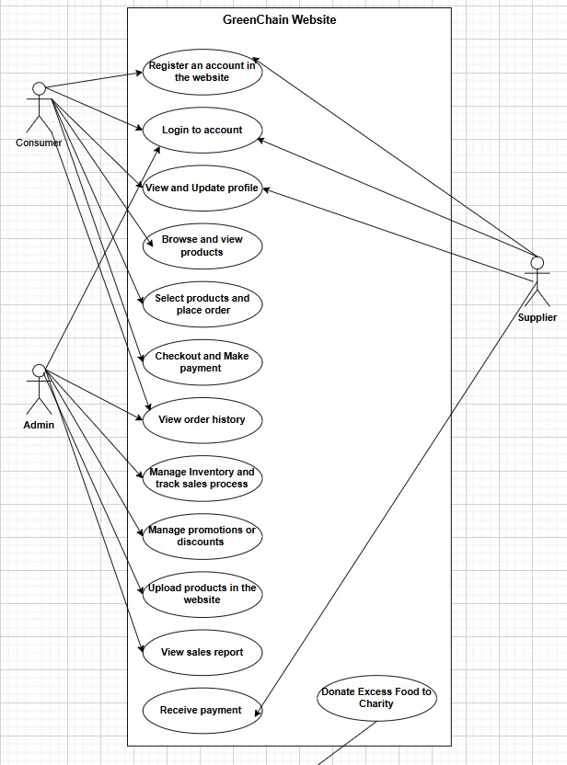

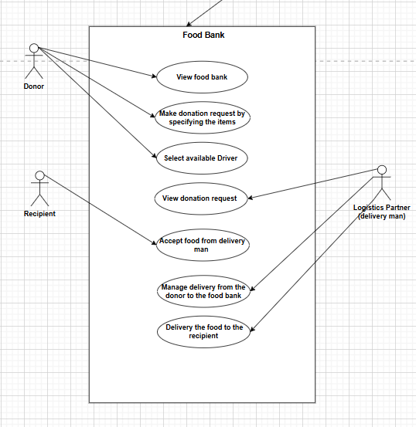

Figure : GreenChain Use Case View

## 4.2 Activity Diagram

### 4.2.1 Customer Process Activity Diagram

It begins when the customer either signs in in case they are registered customers or creates an account in case they are not. Once the customer has logged in, they can be able to view the product menu once they have chosen some items and added it into the cart. The customer can choose to view and modify the contents of the cart, remove or cancel some of the items on the cart or go to the checkout page. Finally, the customer chooses the payment option and proceeds with the payment. After an order is placed by the client, the system also sends an order confirmation notification then completes the process.

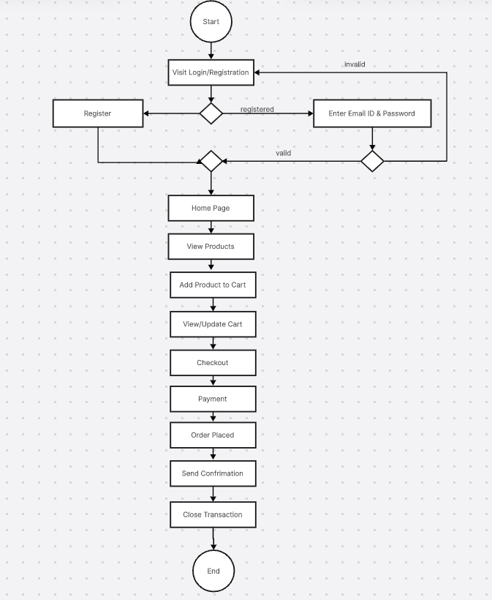

Figure : Customer Process Activity Diagram

### 4.2.2 Food Bank Donation Activity Diagram

In the food bank donation process, the user which will be either restaurant or coffee shop, will first login into the website then from the dashboard, there is a tab called “Food Bank Donation”. They will fill in their name, the pickup time, state the address then indicate the type of food they want to donate as cooked or raw, quantity, description and the best before date if any. Following that, the user chooses the driver. After going through the various details, the user submits their donation form.

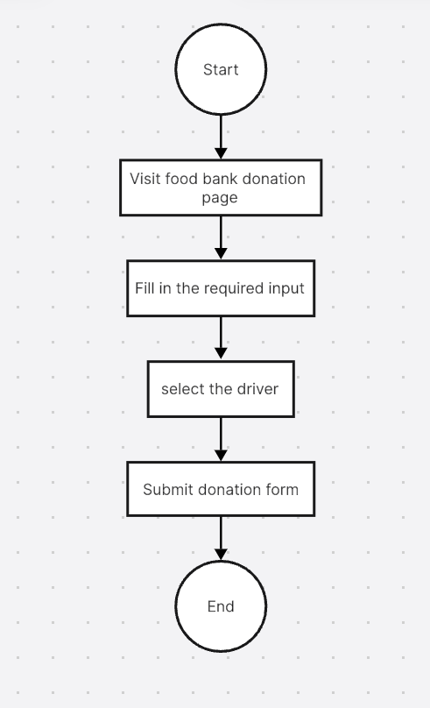

Figure : Food Bank Donation Activity Diagram

## 4.3 Domain Class Model

The domain class model for GreenChain is designed to facilitate sustainable food supply chains through an innovative e-commerce platform. Consumers can browse products and place orders. Products offered on the platform are supplied by different suppliers. Every product has a price and category, as well as other important information. Additionally, the Orders table is linked to Payments table for payment processing. This comprehensive structure shows the interconnectedness of users, products, orders, and sustainability within the GreenChain platform.

Relationships:

1. Consumer -> Event: **One** Consumer places **Many** Orders.
2. Supplier -> Event: **One** Supplier supplies **Many** Products.
3. Order -> Event: **One** Order is linked to **One** Payment.
4. Supplier -> Event: **One** Supplier has **Many** Compliance Documents.
5. Inventory -> Event: **One** Inventory has **Many** Products.

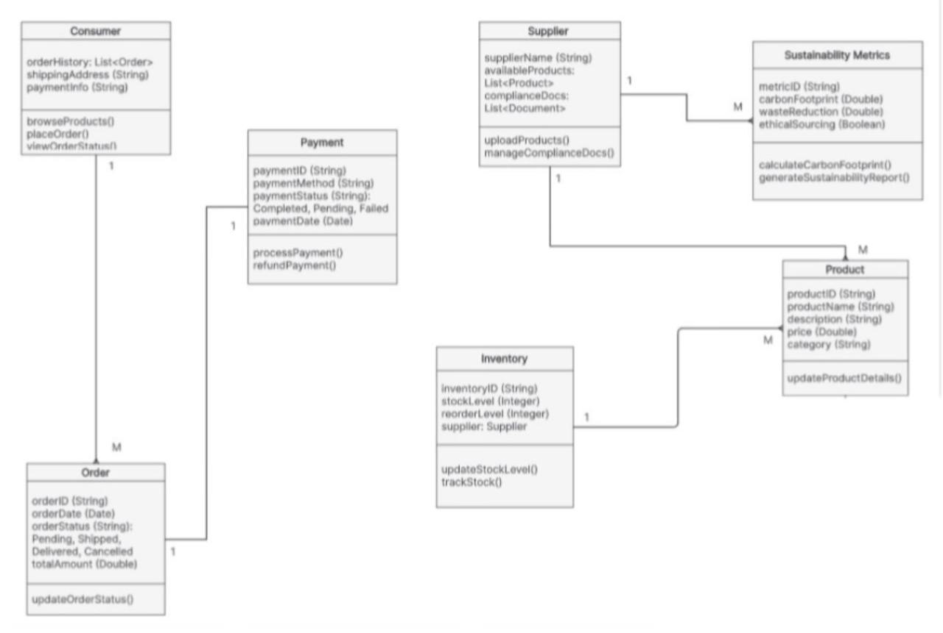

Figure : Domain Class Model View

## 4.4Sequence diagrams

### 4.4.1 Order Sequence

This figure below shows the process for purchasing products on the GreenChain website. This process consists of different roles, the customer, the website, supplier, the payment gateway and the delivery/courier service. The customer goes on the website and searches for a product, the website displays the different products, the customer then selects from these products. The results are then displayed to the customer whether if a product is in stock or out of stock the customer then continues to add or delete items from their cart, shortly after a pop-up message is sent from the website which says proceed to check out, customer then chooses yes or no.

If yes customer is connected to payment gateway where they enter their pin, if it is correct transaction is successful else transaction has failed, however if transaction is successful, payment is confirmed then a delivery message is sent to the delivery/courier services to deliver this product to customer and a message is sent to customer stating order is confirmed.

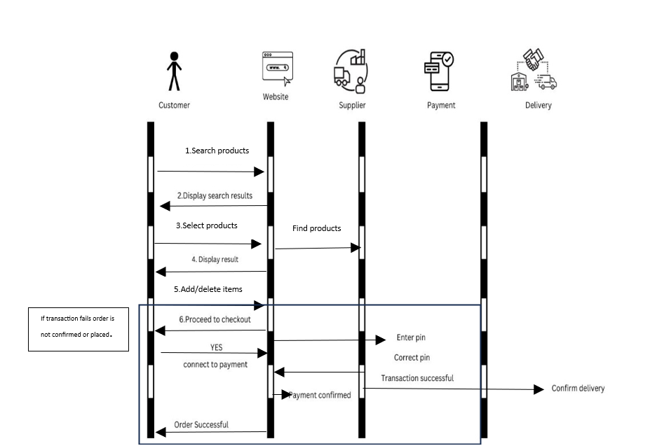

Figure : Order Sequence Diagram

### 4.4.2 Foodbank Sequence

The figure below shows the food bank request process, the roles involved are the customer/user, the website, the food bank page and the driver/courier.

The user logs into the website and clicks on the food bank page, the website then redirects the user to the Food bank page, the user then makes the request on the foodbank page where they enter the food item details, the pickup time and which driver they have selected. The Food bank page then sends a confirmation message back to the user and the feedback page also sends an automated delivery pick up message to the driver and at the same time the food bank page also sends a notification to the admin page on the website stating a donation request has been made. The driver then picks up the delivery from the restaurant at the selected pick-up time and the delivery courier sends it to the charities.

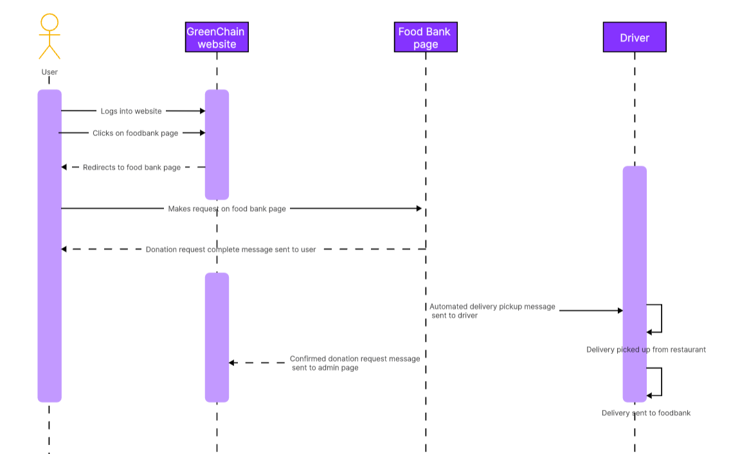

Figure : Foodbank Sequence Diagram

## 4.5 User Interface Design

During the design phase of our “GreenChain” Website. We have visualized a rough idea about our website and its main UI components and features. After a long discussion with our team members, we have come up with a final design for our website. Since majority of our customers are going to be the restaurants and coffee shops, we have come up with a very user-friendly and easy to use interface design. It has straightforward navigation with distinct sections for each user type, allowing them to efficiently manage their activities on the platform, which will provide and seamless experience for our users.

In the figure below represents the interface and basic functionalities for our “GreenChain” website such as the Home page, login page, registration page, product page, food bank page and so on.

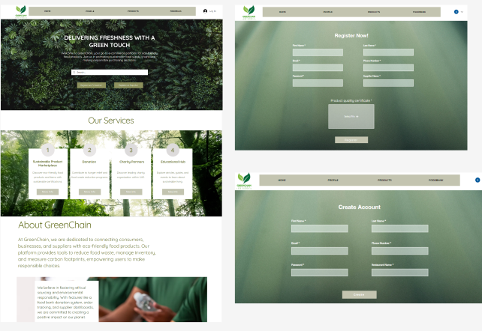

Figure : User Interface-1

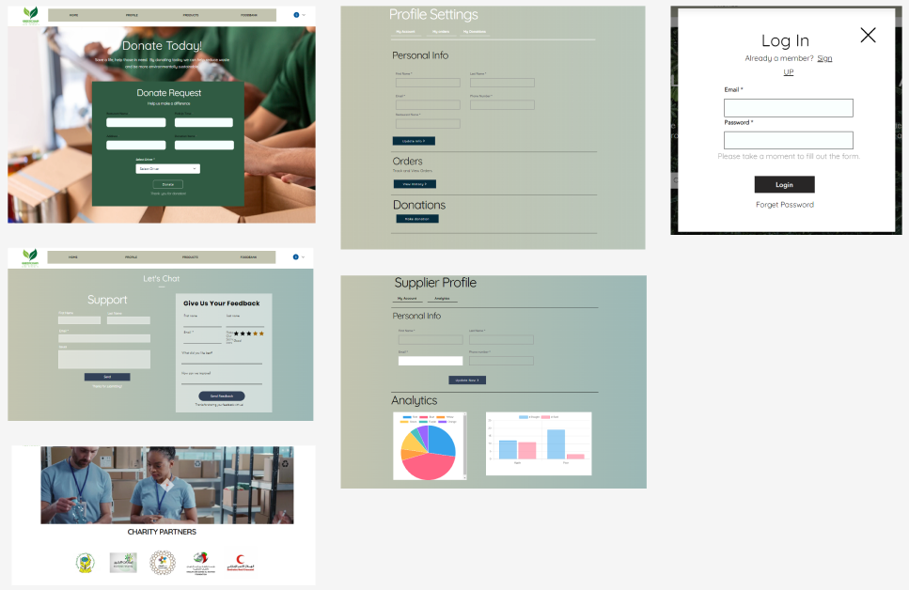

Figure : User Interface-2

## 4.6 Architecture Diagram

The figure below shows the website architectural diagram where it starts from the homepage and from the homepage, the connected pages will appear as different buttons or on the navigation bar. When we click on supplier registration page or customer registration page, we move onto login page to confirm registration credentials, where we then allow the supplier to be able to access their supplier profile page where they can edit details and view their products. However, customer registration page leads to login, profile and much more pages such product purchasing or making a food bank request.

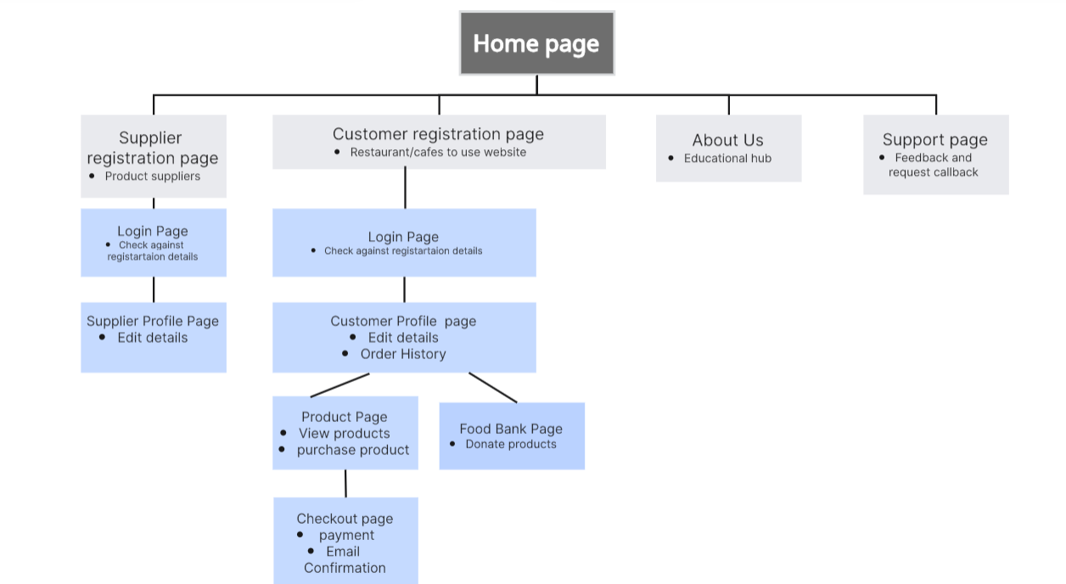

Figure : Architecture Diagram

## 4.7 Network Diagram

GreenChain's network architecture aims to offer a safe, scalable, and effective e-commerce platform for sustainable food supply chains. Through the HTTPS/HTTP protocols, users can access the platform from various devices, such as desktop computers, tablets, and smartphones. The web server processes requests and exchanges information with the application server to manage business logic, including order management and user authentication. The application server communicates with a built in Wix velo database to hold user, product, and transaction data. Additionally, the application server integrates with other systems, like supplier ERP systems for real-time inventory updating and payment gateways for safe transactions. A firewall safeguards the web and application servers, while SSL/TLS encryption encrypts data during transmission.

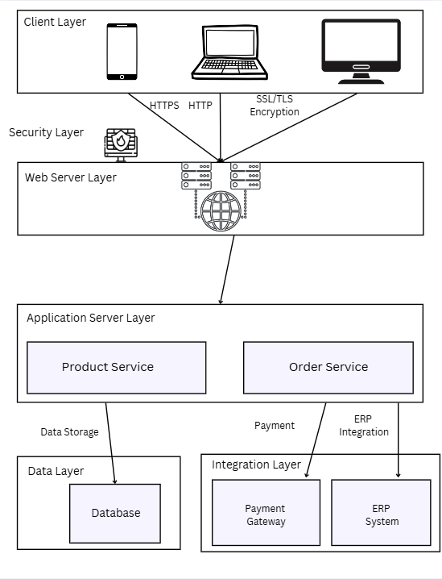

Figure : Network Diagram

# **Chapter Five: Implementation**

## 5.1 Environment

### 5.1.1 Hardware Component

* **Client-Side**

When creating the GreenChain website, it is important to consider the client-side hardware components. These components include the many devices that users will use to visit the website, as it is accessible through laptops, phones, and desktop computers. To ensure a seamless connection with our GreenChain website and the flawless functioning of the website, user devices should be running the most recent versions of their operating systems. Additionally, devices must have the appropriate screen resolution to guarantee that website features are displayed correctly and that users can get the most out of the GreenChain website on any device.

* **Server-Side**

GreenChain does not require physical servers for hosting because it uses Wix's scalable and energy-efficient cloud architecture. This approach reduces the impact on the environment and the amount of hardware used. GreenChain's sustainability objectives are in line with Wix's collaboration with data centres that run on renewable energy, ensuring an environmentally friendly website with a reduced carbon impact.

### 5.1.2 Software Component

* **Wix Platform**

For GreenChain, Wix provides a complete platform that manages necessary tasks like payment processing, and responsive design without the need for other applications. Its integrated features, such as automatic updates and SEO optimization, improve security and visibility. Wix also guarantees a smooth user experience by delivering material quickly and efficiently.

* **Database Management System**

GreenChain stores and manages information like user profiles, order history, and product details using Wix's own database management system. Wix's cloud-based database infrastructure provides scalability and dependability, guaranteeing that GreenChain's website will continue to operate without the need for extra hardware or other database management systems as it expands.

### 5.1.3 Network Configuration

* **Networking Hardware**

Wix's advanced cloud infrastructure distributes traffic and resources across international data centres, ensuring GreenChain's dependable performance. By doing this, even during times of high traffic, downtime is avoided, and a flawless user experience is maintained.

* **Security Configuration**

Wix provides strong safety features to protect GreenChain's users and data, including firewalls, SSL encryption, and secure data storage. Without the need for third-party services, continuous protection is ensured by automatic upgrades and security monitoring.

* **Internet Connectivity**

GreenChain's website performance is improved by Wix's global CDN, which delivers content fast depending on the user's location. Even in places with weaker internet speeds, this ensures smooth browsing, faster load times, and less energy consumption.

## 5.2 Technologies Needed

* **Website Development and Database Management**

Wix is the development platform that GreenChain uses to create and host its website, making use of its secure hosting features, integrated e-commerce facilities, and user-friendly interface. User profiles, product information, and order history can all be safely stored and managed by using Wix's integrated database management. While integrated security features like firewalls, encryption, and automated updates protect user data, these components ensure effective data handling and seamless website operations.

* **User Experience Features**

A consistent and user-friendly experience is provided by responsive design technologies, which ensure that the website works flawlessly on PCs, tablets, and mobile devices. In keeping with GreenChain's sustainable objective, customisable themes improve the platform's look and provide an easy-to-use interface for suppliers and customers both.

* **Technology Integration for Efficiency and Scalability**

By integrating these technologies, GreenChain ensures a great user experience while ensuring safe, effective, and scalable operations. These features establish GreenChain as a reliable and sustainable e-commerce platform in addition to improving supply chain management.

## 5.3 Programming Languages and Database Systems

* **JavaScript**

The image below shows JavaScript code which is tailored for Wix. It is called Velo, and it is a built-in programming language for Wix, Velo enables developers to advance their websites by custom writing their code and adding multiple features like data handling and user management.

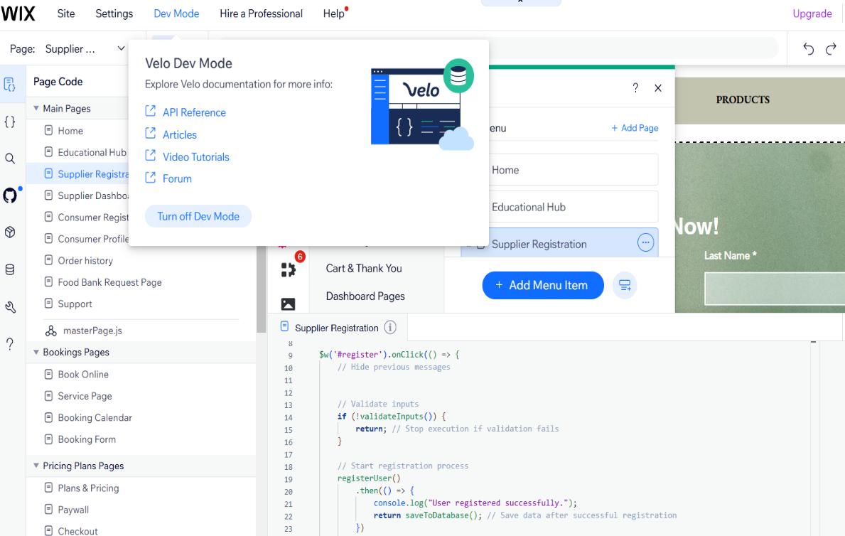

Figure : Dev Mode View

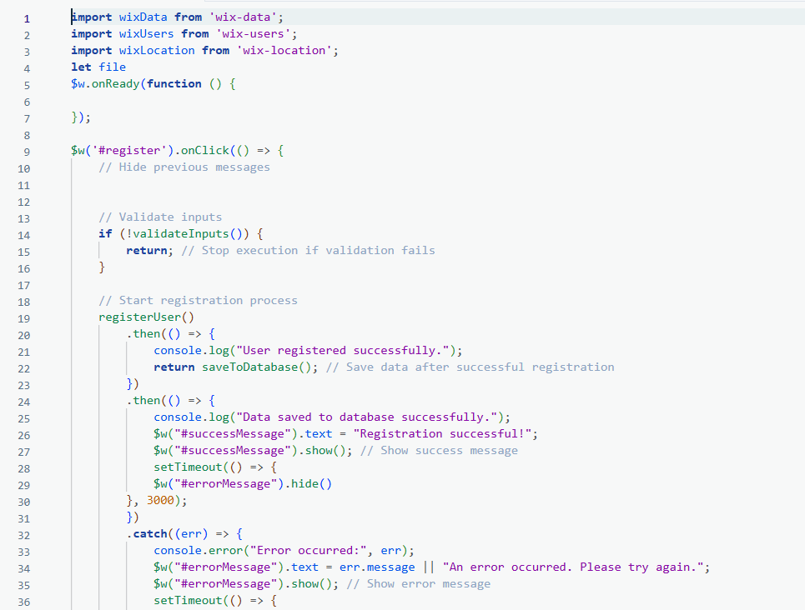

Figure : JavaScript for Consumer Registration

* **Database**

The image below shows the database collection within Wix that we have named ‘Customers’. This is part of the database management system that is provided by Wix this database stores customer data such as first name, last name and email addresses. These databases can be customised and managed through the Velo provided by Wix. There are multiple features and tools that help us modify and manage these fields, this database is seamless and provides accurate backend operations.

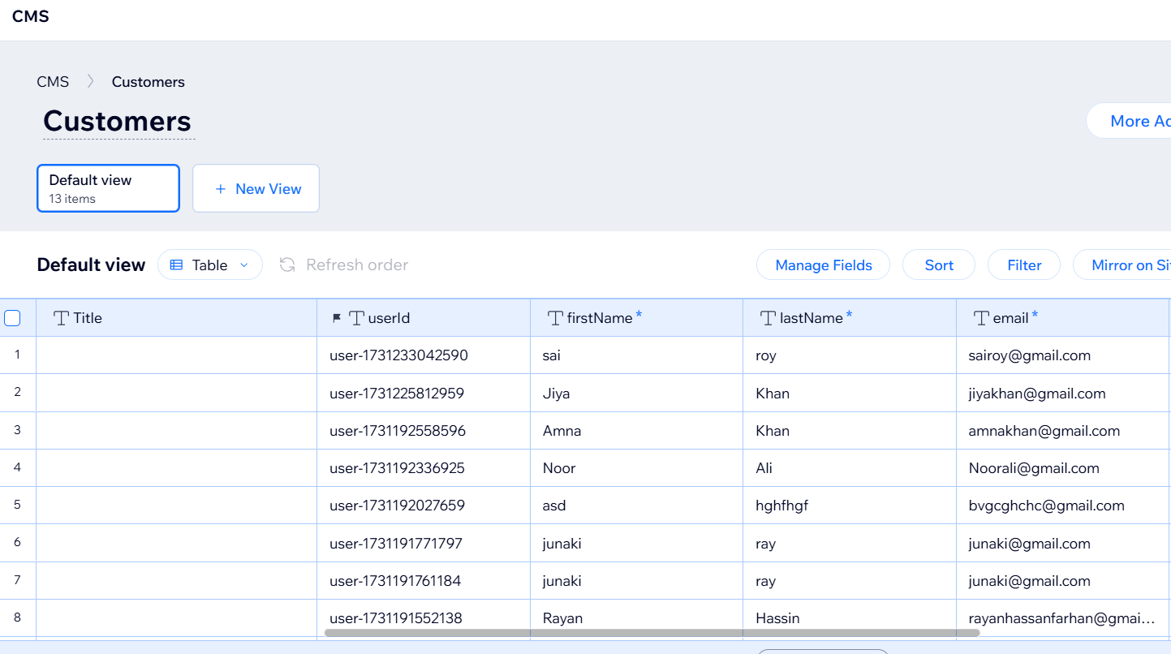

Figure : CMS View for Customers

## 5.4 Evaluation/Testing Measures

* + **Functional Testing**

Functional testing makes sure that our Wix website is working the way we wanted, the main functionalities were tested such as product purchasing, submission of forms and notifications. Each feature worked properly. This ensures we have a seamless website which also supports user experience and website performance.

* **Forms and Submissions**

The image below shows a form submission for a food bank page on the Greenchain website, It shows the different submissions that were made with the different fields for example, the restaurant name, pick-up time and address. These donations are likely to be sent to a charity or a food bank location. Wix helps manage and collect this information and responses and save them in the database which can help with donation tracking and delivery planning. This data can also be used to be displayed on the site or other purposes.

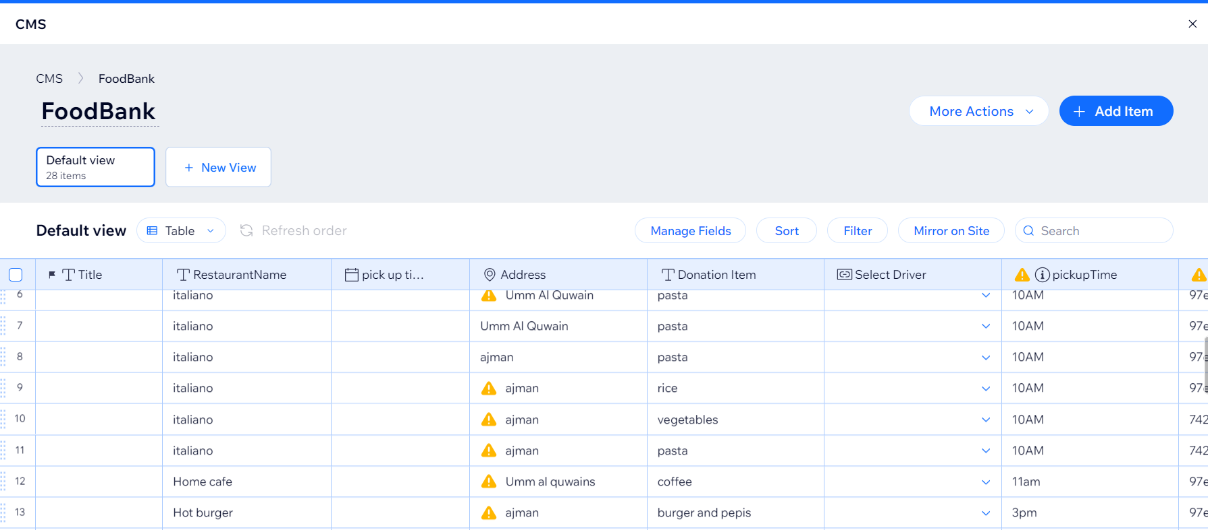

Figure : Data Stored In Donate Now Collection

* **Email Notifications**

The email notifications on Wix have been successfully tested and is properly working and functional. Customers receive email notifications whenever they make a purchase order, this includes the confirmation, the account details and the products purchased. The notification is sent to the email provided by the customer, the email is responsive and immediately sent, there are no delays and no duplication of messages. This shows clear functionality and helps keep the customers satisfied and trusting.

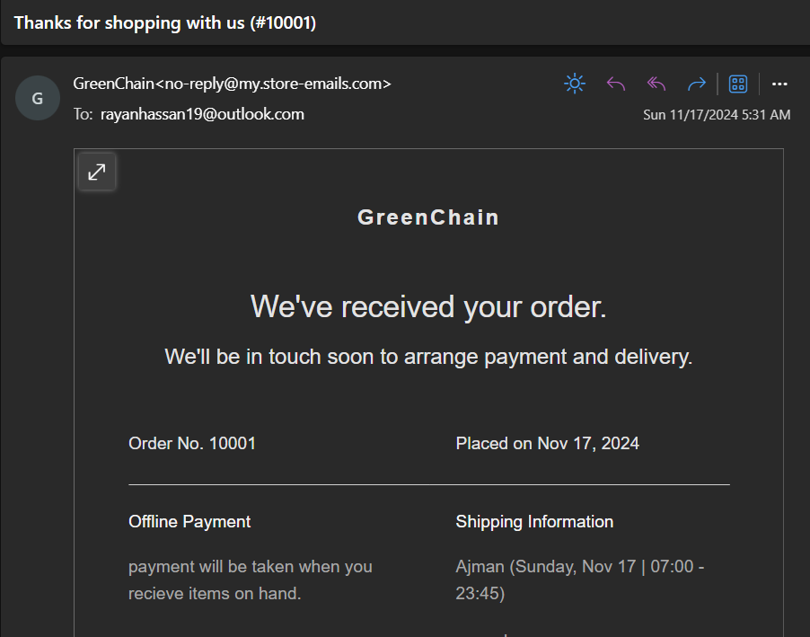

Figure : Order Confirmation Email

* **Menu Bar and Links:**

The menu dropdown that is used on Wix is fully functional and has been tested. Customers can navigate using these drop-down menus and they will be correctly redirected to the chosen field. There are multiple filters and/or segments. The menu responds quickly, and customers can easily navigate between products without any delay. All fields in the drop-down menu are clickable and helps with the user experience, this also helps customers browse easily and find products faster on the website.

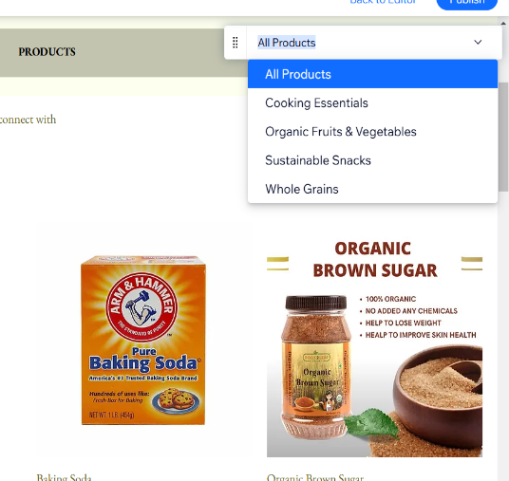 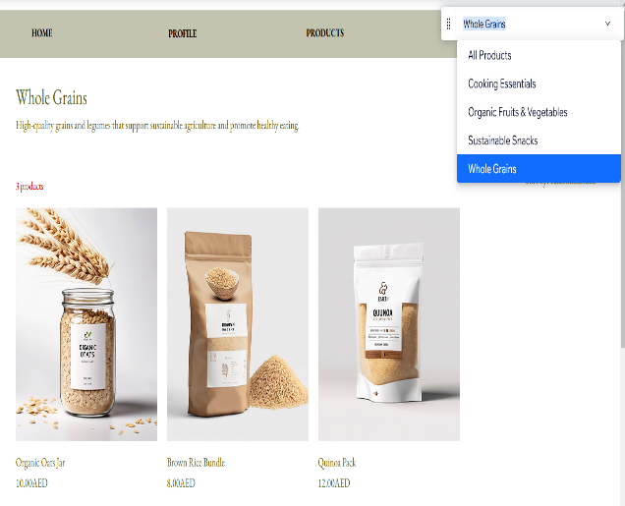

Figure : Dropdown Menu

* + - **Non-Functional Testing**

Non-functional testing for our website was mainly focused on how the performance is and the usability we checked the speed of the website to ensure that everything is navigating smoothly, and we made sure that with increasing traffic it would still load the same. We also checked the website responsiveness and redirection to multiple pages as well as how it would work on different devices for example, mobile. This test made sure that the website functions well and it is user-friendly and high performing.

* **Mobile Responsiveness:**

For the green chain website, we made sure that the mobile responsiveness works, and we also verified that the sizing and the functions are seamless on the mobile display. We made it fit to the screen sizes, we made sure to test the layout and all the elements to make sure it has scaled effectively, this helps user enjoy browsing on our website and have a great experience overall regardless of what device they choose to view our website.

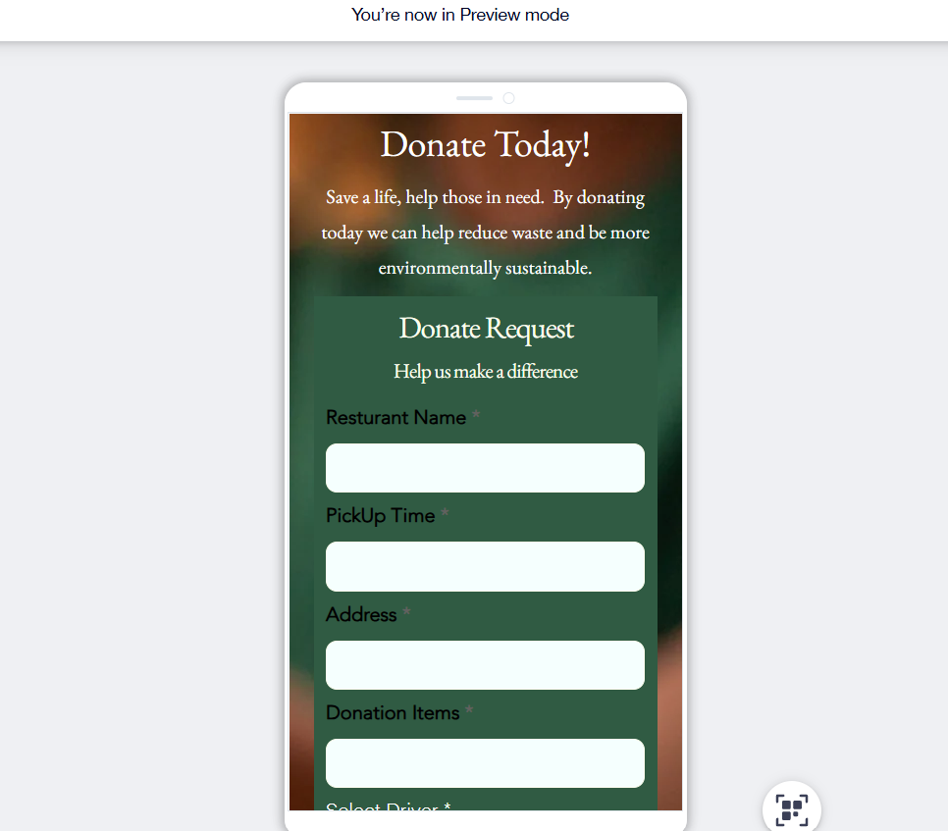

Figure : Mobile Responsive View

* **Dashboard**

For our dashboard we make sure to check if its performance was quick and effective, we made sure that all trends and activities as well as statistics show. We made sure the dashboards capacity can handle large amount of data, and it should still be able to visualise the activity status to us on our dashboard. This helps show our reliability and the activity on our website, our analytical dashboard below shows that it is operating smoothly and efficiently with high-performance.

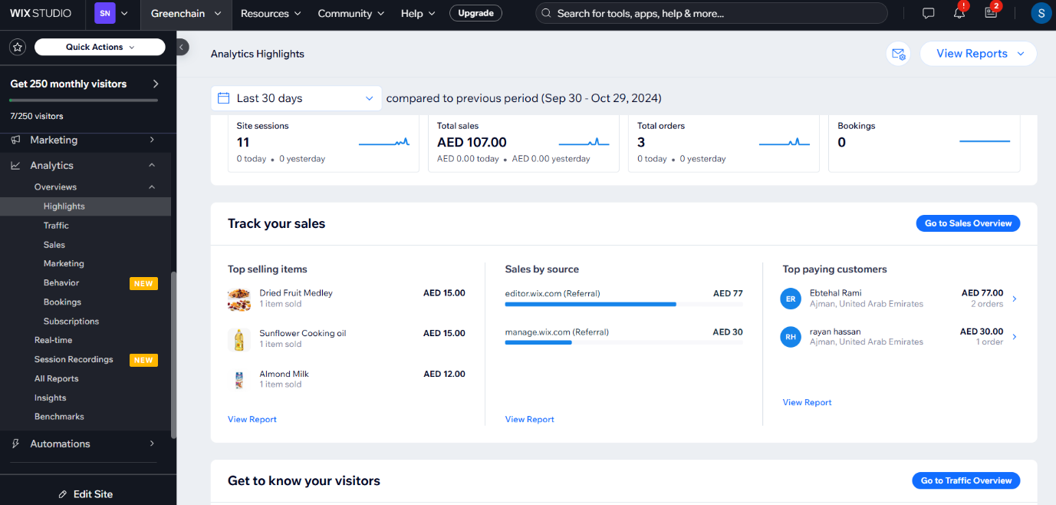

Figure : Admin Dashboard View

## 5.5 Testing Plan

To ensure that the website works according to its functional specifications and provides a smooth user experience, numerous testing methods were employed. This plan included independent testing of each component as well as testing of the interactions of two or more components.

**1. Input Validation:** Every input fields were checked to verify that they would meet predefined validation rules. For instance, the password input box was subjected to a test to ensure that it allows only 6 to 15 characters, including at least one uppercase, and one special character and other tests that check for invalid inputs to ensure that it returns adequate input error messages.

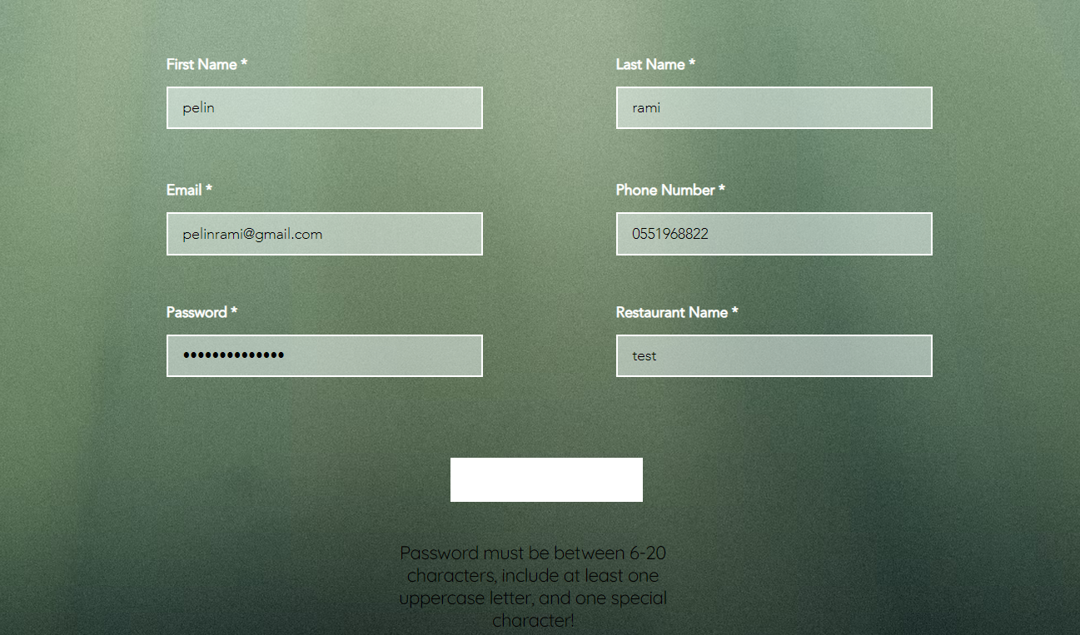

Figure : Input Validation View

**2. Functional Testing**: The proof of successful execution of all the other features of the website was ensured through vigorous testing of all the features. For instance:

* The experience designed in the products page was checked and confirmed to allow for selection of products and addition to the cart.
* The cart functionality was tested to ensure that everything that a customer needed to see including items selected, their quantities as well as prices were well displayed and adapted upon any changes by the customer.
* The checkout process was checked to confirm that it offered a seamless functionality and required fields had been completed, and that the user gets a confirmation massage for the order.

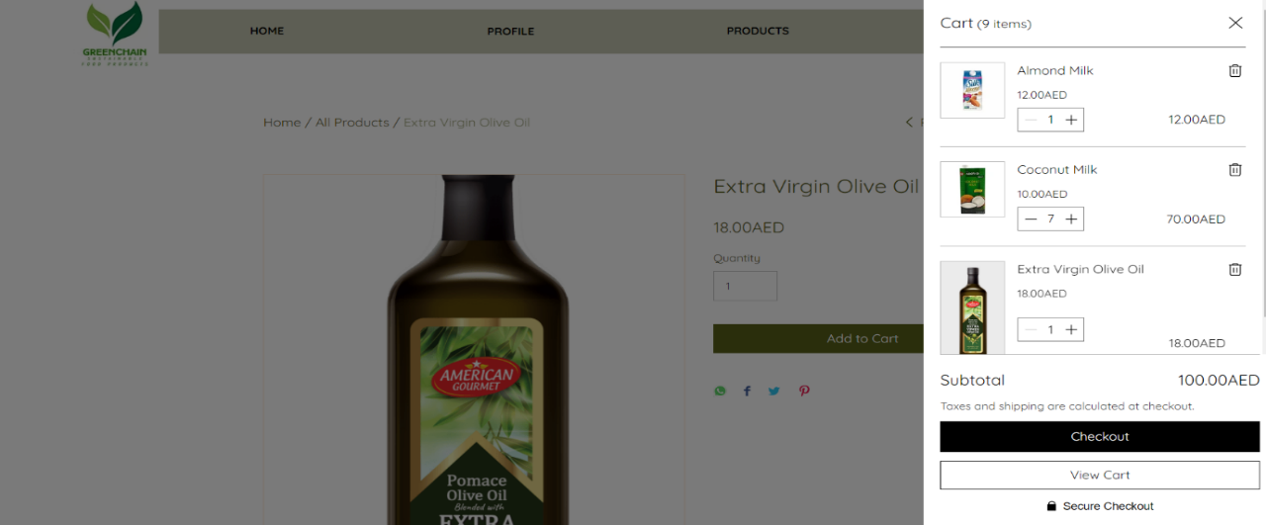

Figure : Add to Cart Functionality Testing

**3. Integration Testing:** The interface of each module was with the other to confirm the fluency of activities between them. For instance, when a customer has a website interaction involving a checkout on one of the pages, the system was checked to find out if an order confirmation was automatically sent to the provided email. The information in the email messages was also checked to see if each of the necessary order specifics namely product name, quantity, price, and estimated delivery date etc. were included.

**4. Usability Testing**: Besides technical verification, the website experience was checked by other persons to find out whether there are any usability problems that can appear at first glance, for instance, the navigation problems or unclear guidelines to accomplish a definite task in order to create an effective and user-friendly interface.

**5. Edge Case and Stress Testing:** Some of the scenarios that were performed include testing of large quantities of products or appending large numbers to the product, multiple and simultaneous access of check out and cart.

Hence putting in place these testing approaches we were able to determine whether these components are functional individually and jointly to meet the user requirements. This comprehensive testing plan ensures reliability of use on the side of the stakeholders and ease of use across the board.

## 5.6 Implementation Plan

The initial step of our implementation plan for GreenChain was to gather information and Identify user needs; to achieve this information, we have conducted surveys and interviews with our target consumers, such as local restaurants and coffee shops, to understand their business in a better way. This process plays an important role in determining the scope and goal of our website.

The survey and interviews include inquiries regarding their existing business process of Product purchase and how they handle excess food waste as well as how to assure the quality of the product they serve the customers, we also enquired about the difficulties they faced running restaurants and coffee shop. During the query we have understood that the restaurants have to handle multiple suppliers to buy multiple products and most of them Used many packaged foods which is not sustainable enough, which can cause health problem to the food consumer. Therefore, we have come up with a website which will solve the problems for many restaurants and coffee shops where they can buy sustainable organic products as well as reducing food wastage by donating the food to our website.

Right after collecting the necessary information, the next step was to visualize and create a design prototype for our website. Therefore, we have used the website called Figma to create prototypes for our website. Figma is a well-known design program, which allows the users to create collaborative design, prototyping and help with teamwork. Below figure represents the prototype for our website. However, there have been certain changes that have been made to the interface of the website to make it more appealing for the users.

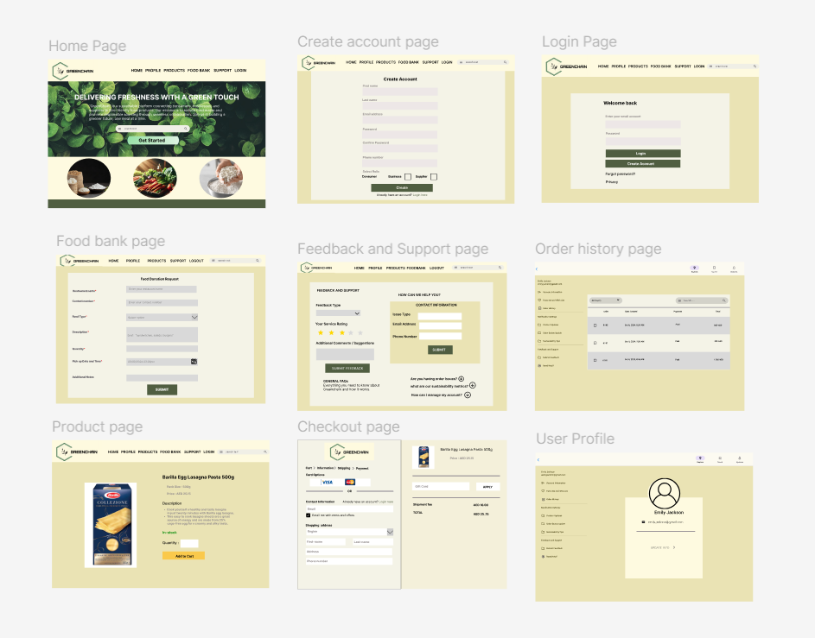

Figure : Website prototype using Figma

After the design and layout have been developed, the next stage of the website implementation strategy is to create the real website. To develop the website, we used Wix platform, which allows us to build the website utilizing Wix’s built-in functionalities, programming languages, and Database that helps to create responsive and dynamic website aligned with user needs.

Later, we started by creating our home page for the website considering the visitors will view the home page first. Therefore, we have designed a visually appealing home page as well as making it easy to navigate. Below is the detailed information about the website along with its functionalities.

* + - 1. **Home Page**

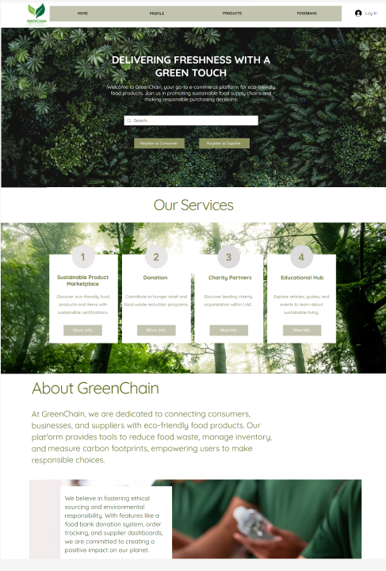

Figure : Home Page View

**Main functionality**

* Starting with the header of the home page, which consists of the logo and navigation bar and buttons like home, profile, products, food bank, login. which will help the users to navigate easily between the pages.
* Below the navigation bar is the slogan of our website “Delivering freshness with a green touch”. Followed by two buttons off registration Which allows users to register as supplier or consumer. By Clicking on register as consumer will redirect them to the consumer registration page
* Next section of the homepage shows the services that are provided by our website such as sustainable product marketplace redirecting them to the product page. The donation and partnership redirect them to the donation or food bank page. The educational hub provides different articles related to sustainability and the food industry to improve the user knowledge.
* Next is the about us section which provides information related to our website GreenChain.

**2. Supplier & Consumer Registration Page**

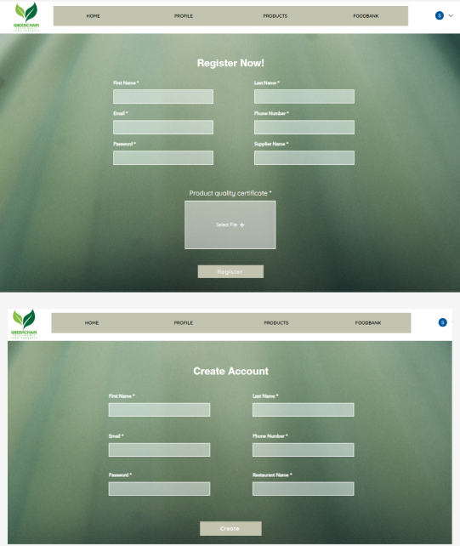

Figure : Supplier & Consumer Registration Page View

**Main functionality**

* This form allows the user to register as a supplier by providing their personal information like first name, last name, e-mail, phone number and so on.
* The supplier must submit a legally verified product quality certificate to show they are supplying sustainable products and protected by law.
* Once the supplier submits the form his information will be stored in the supplier database along with a certificate and at the same time it sends a message to the admin saying a new member has been registered on the website, which is only accessible by the admin.
* We have also created a consumer registration page which allows the users to register as a consumer and their information will be stored in the consumer database.
* The difference between consumer and supplier registration pages is that the supplier need to provide a product quality certificate where the consumer don't need it.
  + - 1. **Login Page**

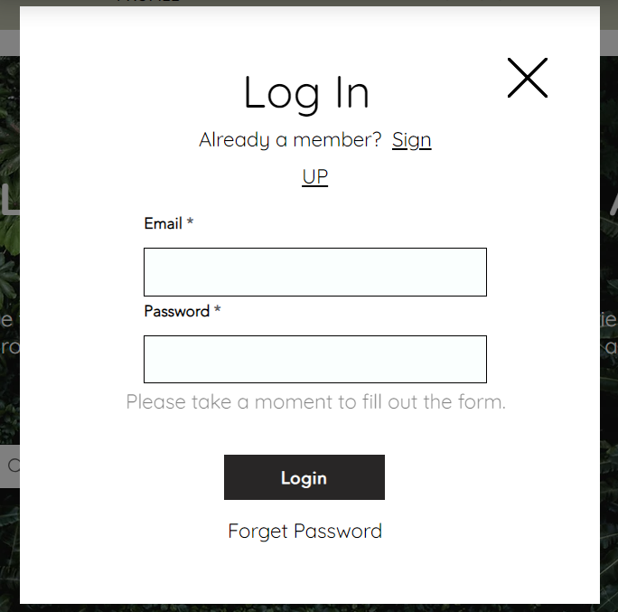

Figure : Login Page View

**Main functionality**

* Once the user is registered to the website, they must log in using their e-mail and password
* The login form will only allow registered members to login to the website or else it will give an error message asking the users to create an account to login

**4. Consumer Profile Page**

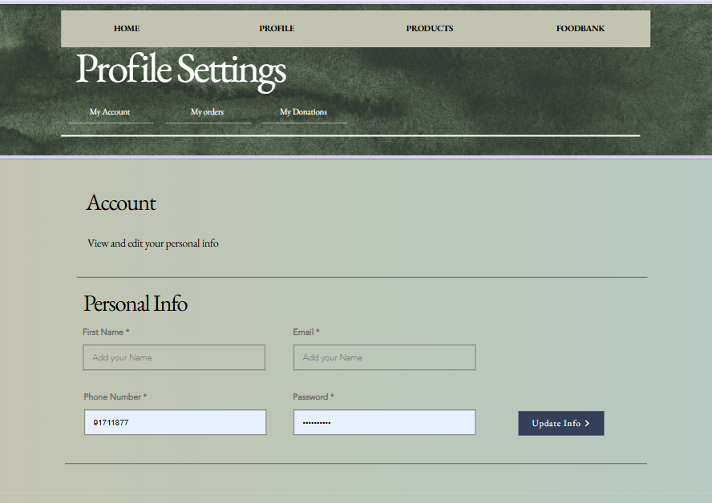

Figure : Consumer Profile Page View

**Main functionality**

* The consumer profile page allows the consumers to view their personal information and update them.
* It's a scrollable page which allows them to move by scrolling or clicking on the desired buttons within the page.
* It also allows the consumer to view their order history by clicking my order settings.
* The consumers (restaurants) can click on my donation which will redirect them to the donation page where they can make a donation.

**5. Supplier Profile**

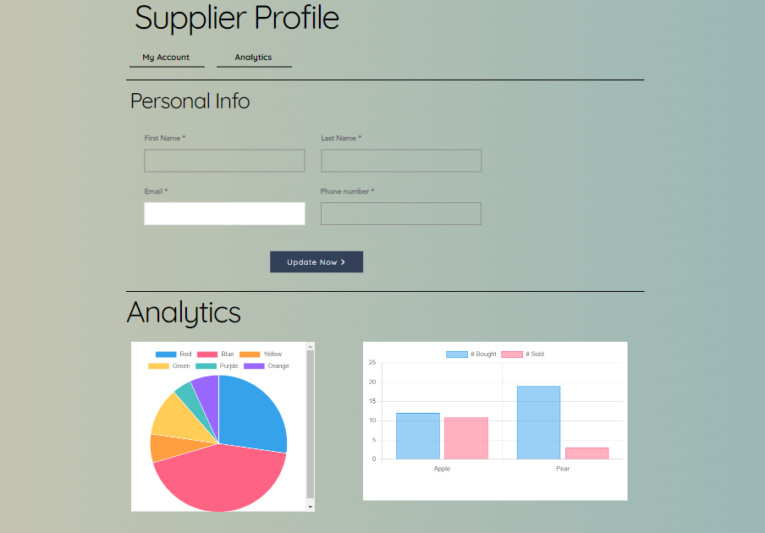

Figure : Supplier Profile View

**Main Functionality**

* It will allow the suppliers to edit their profile information.
* We have tried to implement dashboard analytic part for the suppliers, which would have allowed them to see the sales of their products through graphs like bar chart and pie chart, but this functionality is restricted by Wix because it has its own limitations.

**6. Products Page**

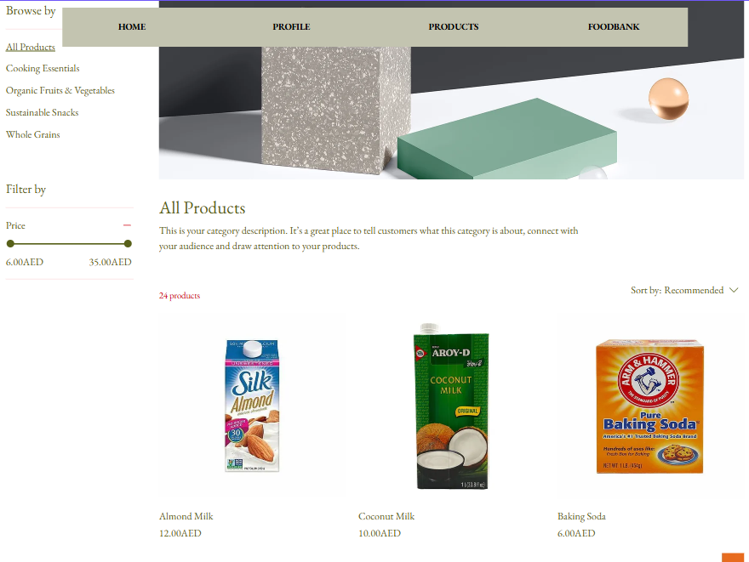

Figure :Products Page View

**Main functionality**

* The product page consists of a list of products that are available on our website along with its details and price.
* Our website mostly sells organic and sustainable products.
* It also allows the user to sort the products by their categories such as cooking essential, sustainable snacks, organic fruits and vegetables, which makes it easy for the consumer to find the product fast.
* All the product information is stored in the Wix default product database.
* It allowed the users to add any kind of product into the cart by simply clicking on the products
* It also allows the user to edit the quantity and add or delete it from the cart.

**7. Food Bank Donation Page**

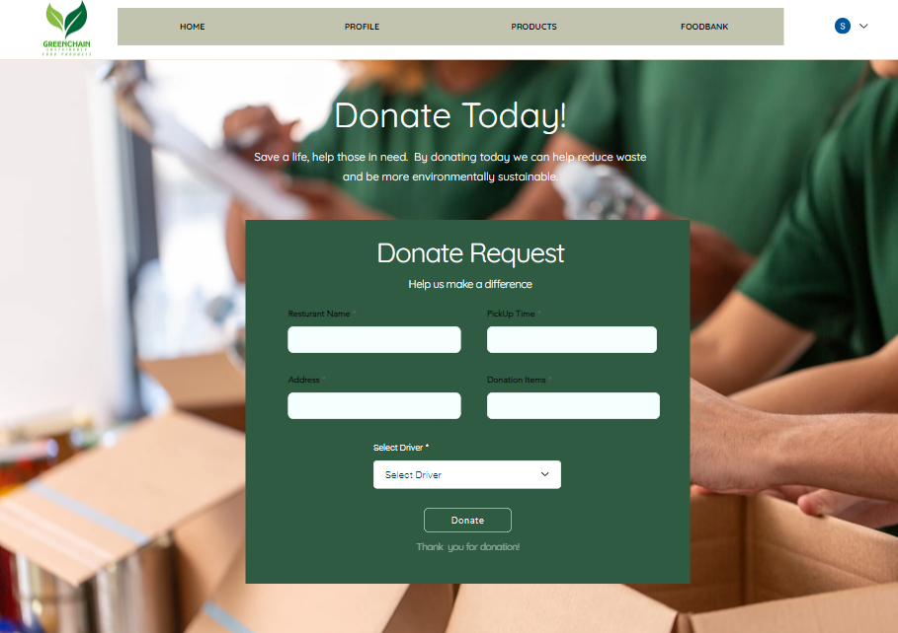

Figure : Food Bank Donation Page View

**Main functionality**

* It allows the consumers (restaurant and coffee shops) to donate their surplus food which will reduce food wastage.
* The donor can donate food to our website by submitting a donation request.
* The donor must fill in all the required information such as the restaurant name, pick up time, address, donation items (specifying the list of items that they're going to donate).
* It also allows the donor to select the driver based on their state and availability of the driver and submit to donate.
* Once the submission is done then one message will be sent to the admin saying a donation request has been made and at the same time it will send a message to the selected driver to pick up the food.
* It will store the information about the donation in the food bank database.

**8. Charity Partners Page**

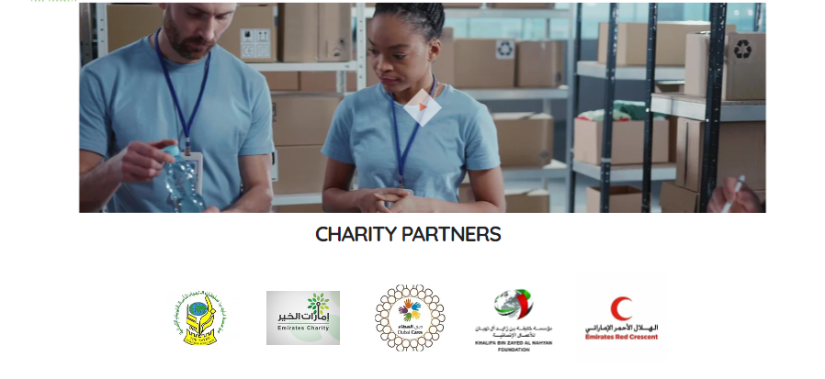

Figure : Charity Partners View

**Main Functionality**

* This page shows the list of leading charity organizations within UAE that we are partners with.
* It has a short video that shows the food packaging and donation.
* Once the consumer donates food to the GreenChain then we contact our partner charity organization and donate the food there.
* Contacting the charity organization is not automated by the website it is done manually by us.

**9. Support & Feedback Page**

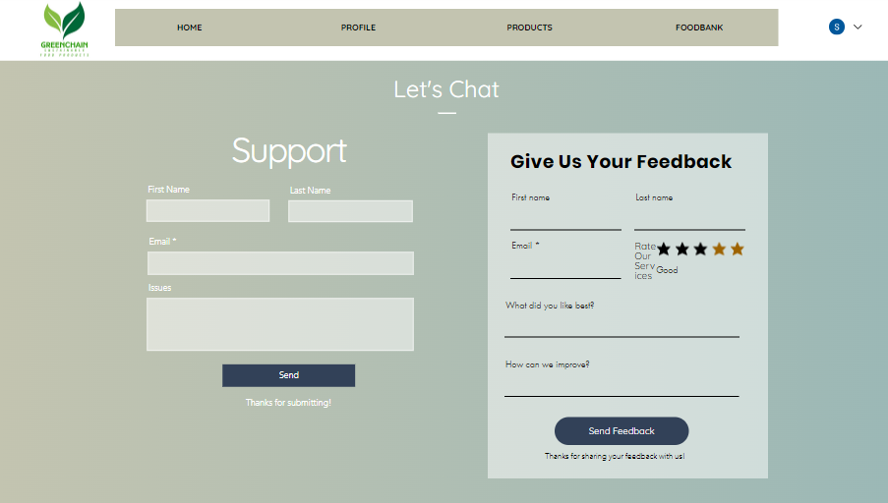

Figure : Support and Feedback Page View

**Main functionality**

* We also provide support functionality for our consumers as well as the suppliers.
* If users have any questions regarding the website or any kind of difficulties during the purchase and donation, they can contact our support team by filling in the support form.
* It also allows the users to give their feedback on our service by submitting a feedback form as well as they can rate us based on their experience.
* Improvement will be taken into count based on the user feedback.

# **Chapter Six: Conclusion**

## 6.1 Strengths and Weaknesses

Here are some of the strengths and weaknesses we gained throughout our experience of using Wix to create our GreenChain website:

**Strengths:**

* **Improved Design Skills:**

We gained a better understanding of Wix’s drag and drop feature and how to create a user-friendly interface, we also were able to create our own page designs and align it the way we wanted.

* **Enhanced Problem-Solving skills:**

We found a way to work around Wix limitations through researching, coding and other functionalities.

* **Platform Customization Familiarity:**

Gained extra knowledge and experience on how to use tools within Wix to meet project requirements.

* **Customer-oriented:**

Strengthened our understanding on how to modify the website to meet customer needs and simplify navigation and user experience.

**Weaknesses:**

* **Wix Limitations:**

Limited features that we could either not access or had difficulty understanding how to create for example, customizing user dashboards. We also faced challenges on how to track foodbank donation history.

* **Concerns with Scalability:**

Unknown scalability concerns, we are not sure whether issues will arise with scalability or not if heavy data is used.

* **Dependant on Velo:**

We had to rely on velo for coding to customize certain aspects which was very complex initially and this led to time management issues.

* **Unfamiliarity with Wix:**

Initial foreignness with Wix led to slower rate of progress in some areas of website development.

## 6.2 Improvements for the Future

Some improvements that can be made in the future is integrating GreenChain with blockchain technology to enhance traceability and provide trust and transparency, this can be done by providing every product with a written record that documents its path from farm to customer due to blockchain technology. This official history will be able to reduce the risk of fraud and ensures verifiable sustainability claims for all parties involved.

Additionally, we can automate agreements throughout the supply chain and promote responsibility between buyers and suppliers, smart contracts can help further improve compliance. While combined with IoT-enabled traceability, real-time data on temperature, humidity, and handling during transit provides a further layer of confidence regarding the safety and quality of the products.

Furthermore, Live supply chain dashboards can also be enabled so that users can make informed decisions by giving them real-time insights on product locations and sustainability goal progress. We can also expand supplier profiles and interactive traceability maps which give customers clear and engaging methods to learn about product certifications, origins, and sustainability measures. In addition to improving the user experience, these features help achieve SDG objectives including Responsible Consumption and Zero Hunger.

## 6.3 Conclusion

To start with, the concept of GreenChain is a unique solution aimed to address major challenges in food supply chain such as food waste and unsustainable resourcing techniques. GreenChain serves as a platform that will connect restaurants and coffee shops with trustworthy, and eco-friendly suppliers. The project showcases a comprehensive approach from its solid technical architecture to its user-friendly functionalities, to ensure that it meets the need of a wide range of stakeholders, including the consumers and suppliers.

Secondly, the development of process of GreenChain, were focusing on creating a user-friendly platform that can meet the needs of all our consumers, by providing features like food bank donations system and sustainable products. In this way GreenChain offers a practical way to make the food supply chain industry more responsible and efficient. However, in the process of development there are few challenges that we need to take in count, such as budget limitations, sustainable supplier as well as Wix platforms has it's on restriction and limitation for the functionalities which make it difficult for us to make the website more dynamic.

Finally, in conclusion, GreenChain not only addresses the growing demand for sustainable solutions in the food industry but also sets a benchmark for how technology and social responsibility can come together to create a positive impact. The projects clear roadmap, innovative features, which focus on user satisfaction positioned itself as a transformative platform with the potential to contribute to the food industry. We hope this website helps restaurants and coffee shops improve their business processes, making it easier for them to adopt sustainable practice and streamline their operations.

# References

* IBM. (2024). *What is supply chain management?* IBM. Retrieved from <https://www.ibm.com/topics/supply-chain-management>
* Hu, M., Jiang, S., & Huo, B. (2024). The impacts of supply visibility and demand visibility on product innovation: The mediating role of supply chain integration. The International Journal of Logistics Management. <https://doi.org/10.1108/IJLM-01-2021-0033>
* Mastos, T. (2022). Sustainable supply chain management in the food industry: A conceptual model from a literature review and a case study. Retrieved from [https://www.researchgate.net](https://www.researchgate.net/)
* Chef’s Resource. (2024). What is the food industry? Retrieved from <https://www.chefsresource.com/what-is-the-food-industry/>
* Sadiku, M., & Musa, S. (2019). Food industry: An introduction. Retrieved from ResearchGate: [https://www.researchgate.net](https://www.researchgate.net/)
* Prasanna, S., Verma, P., & Bodh, S. (2024). The role of sustainability in food transitions. Environment, Development and Sustainability. <https://doi.org/10.1007/s10668-024-04642-1>
* One Network Enterprises. (2024). Restaurant and food service supply chain solutions. Retrieved from <https://www.onenetwork.com/industries/restaurant-foodservice/>
* SAP. (n.d.). What is a sustainable supply chain? SAP. Retrieved from <https://www.sap.com/products/scm/what-is-a-sustainable-supply-chain.html>
* Gelato. (n.d.). Supply chain sustainability: Everything you need to know. Gelato. Retrieved from <https://www.gelato.com/blog/supply-chain-sustainability#:~:text=Supply%20chain%20sustainability%20initiatives%20in,and%20delivery%20to%20waste%20disposal>
* QSR Magazine. (2023). Sustainability is the future of the restaurant supply chain. Retrieved from <https://www.qsrmagazine.com/reports/sustainability-future-restaurant-supply-chain>

# Appendix

**Appendix A: GreenChain Survey**

